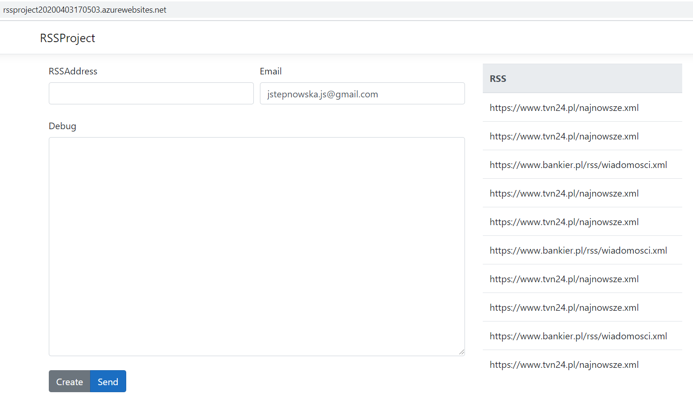

1. Load tests:

* Thread group

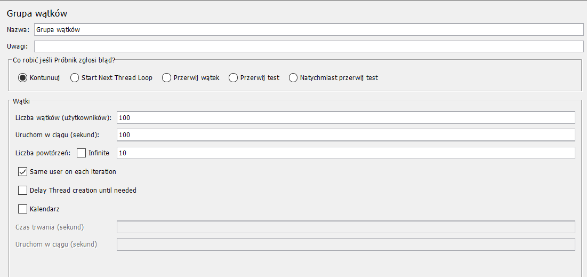

* HTTP Request Defaults

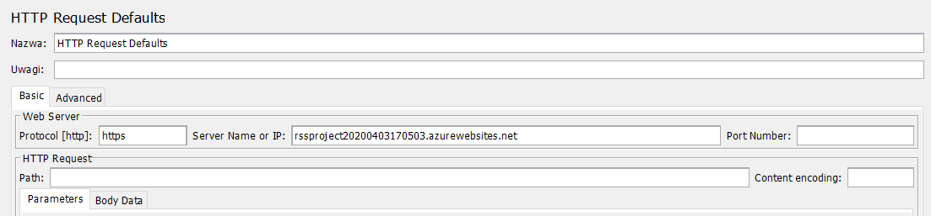

* HTTP Request

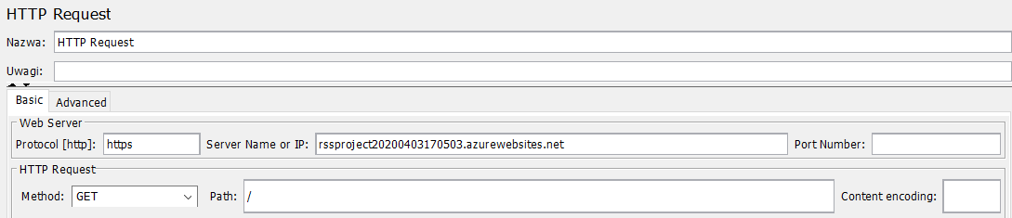

1. Results

* Graph Results

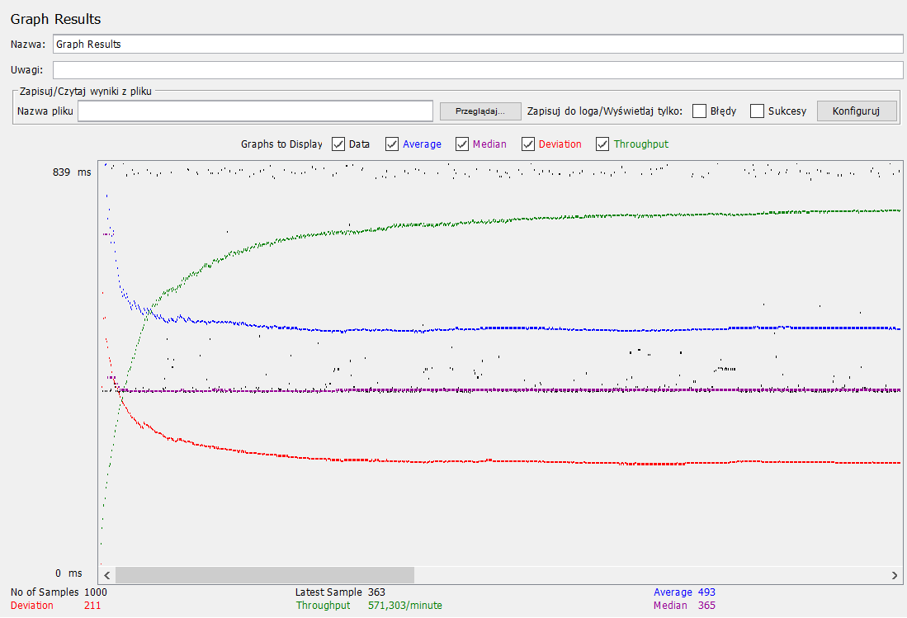

* Results in table



* Final results:

Throughput 571,303/minute

Deviation 211

Average Latency 493,024

Average Sample Time 493,132